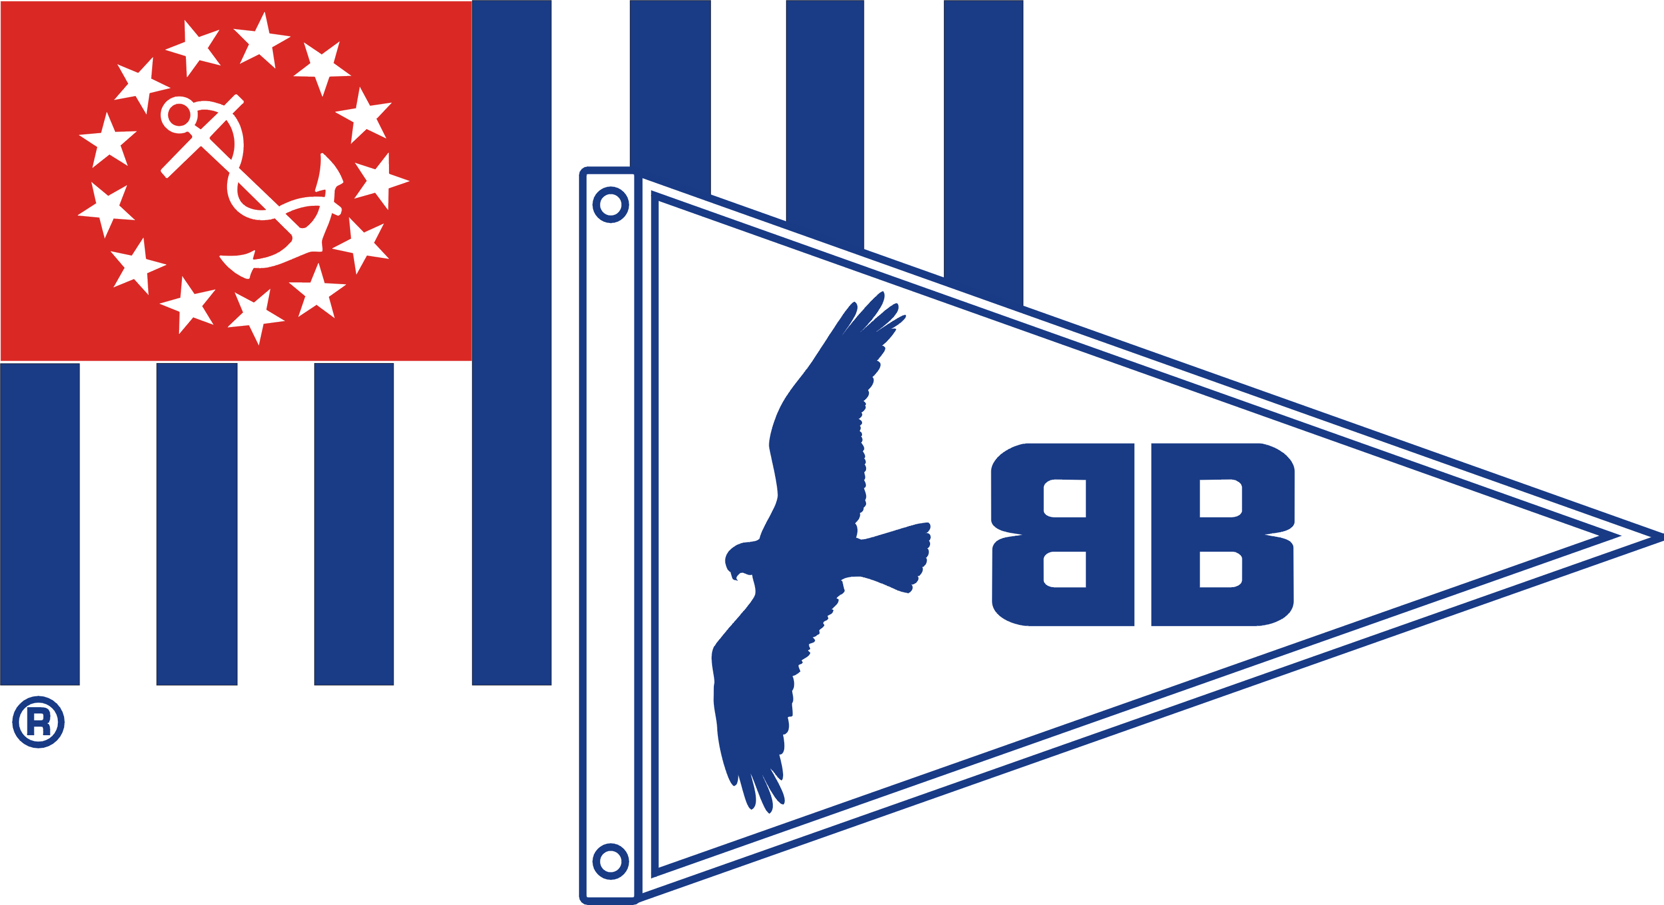
BUZZARDS BAY SAIL & POWER SQUADRON

September 22, 2017

Fellow member,

We are looking for ways to better serve your needs and interest and would appreciate your feedback by taking a brief survey. Help tell us what we can do for you!

To complete the survey, all you have to do is go to the following web address as it will walk you through the survey.

https://www.surveymonkey.com/r/DQMV5N5

Your comments are very much appreciated, as is your participation. All survey feedback is anonymous.

If you would be willing to assist in the squadron, please reply directly to this e-mail to flingard@comcast.net and let us know your area of interest. We would also like to hear any further comments and suggestions over and above those you make in the survey.

We are about to prepare our schedule of activities for early next year and will use your responses in providing programs and activities that you should enjoy.

Best regards,

The Board

